
Actividad 7
Ricardo Fuentes Monter

4 de octubre de 2026
Tecmilenio

Part 1
- Screenshot of the Modeling section, Step 3.
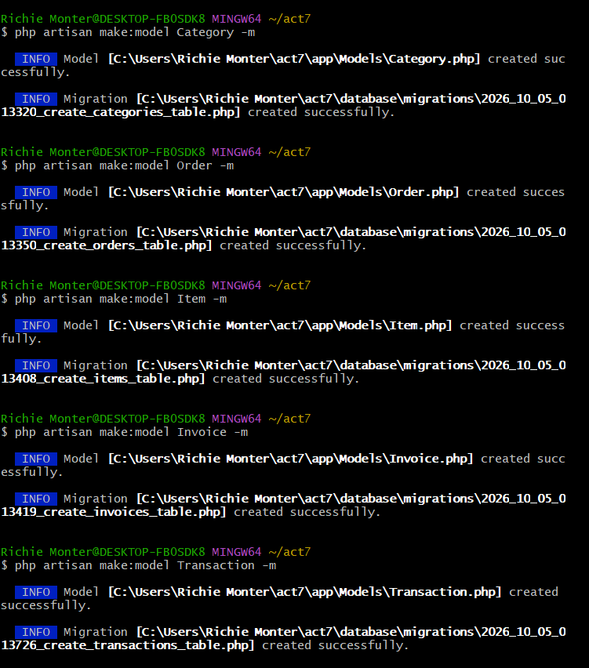
- Screenshot of the Modeling section, Step 4.
- Screenshot of the Migration section, Step 2.
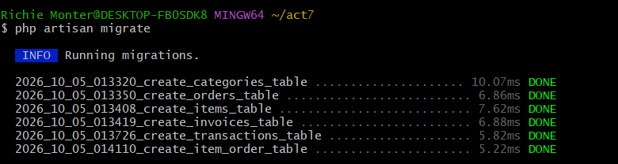
- Screenshot of the tables created using the artisan migrate command.
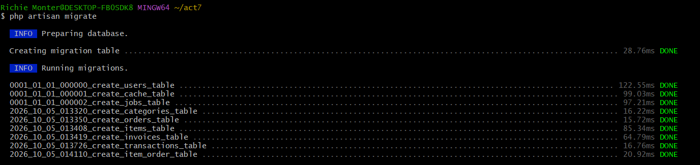
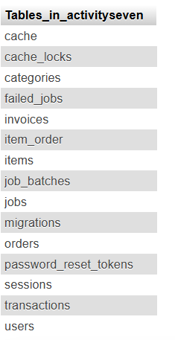
- GitHub link. You must upload the complete folder named act7.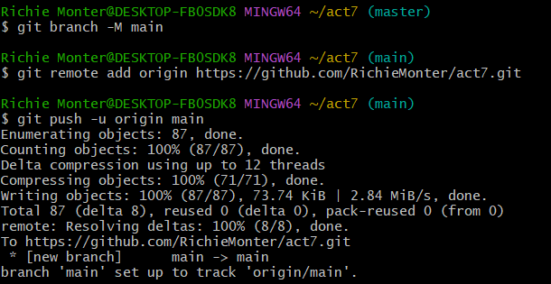
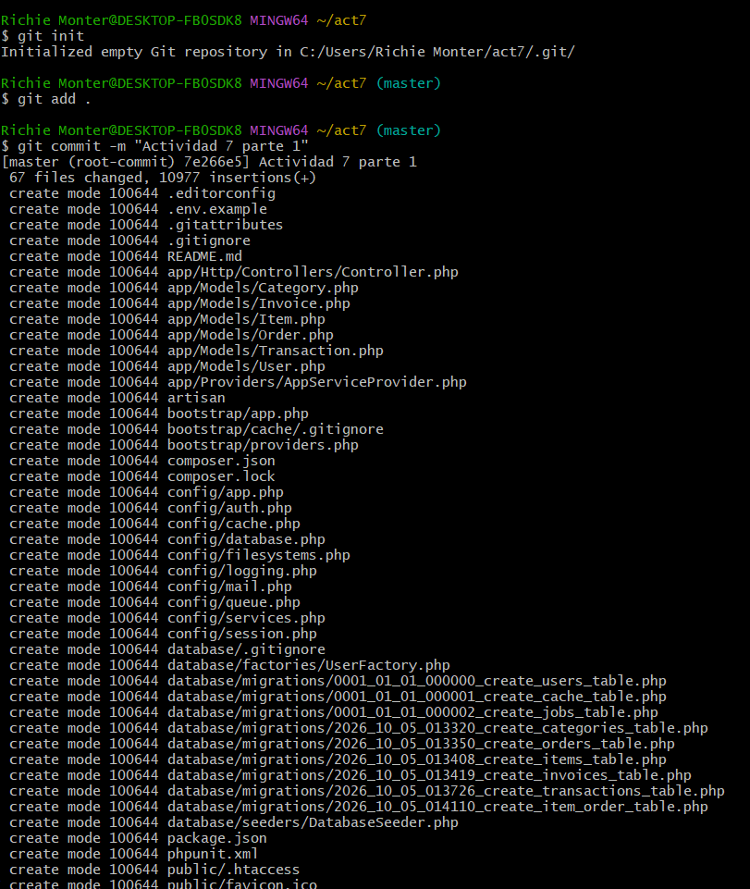
https://github.com/RichieMonter/act7
- Questionnaire
What is the importance of an ERD prior to beginning the development of Laravel?
An ERD is a graphical representation of the database including its entities, attributes and the relationship among entities. It eliminates the design mistakes, the data redundancies, and it make sure that you have good structural filing before writing models and migrations in Laravel.
How is Laravel Model different from Migration?
A Migration is a file describing your database schema's version history that can define, add or modify physical tables and columns in your MySQL database. A Model (Eloquent ORM) is a PHP class that uses those tables to create, read, update, and delete records, query data, and define relationships.
What’s the difference between hasOne() and belongsTo()?
hasOne() is declared on the parent model (the side where the ownership is and does not hold the foreign key). The child model that belongs to parent model will be restricted on foreign key column in which refers to reference the parent table.
What is the difference between up() and down() methods in a migration?
up() method runs the modification to the its database (e.g., adding tables, Adding columns) along with run php artisan migrate do execute. The down() method cancels/undoes all the same exact operations (like dropping tables, or removing columns) when running php artisan migrate:rollback.
What is ORM?
An Object-Relational Mapper (ORM) is a programming methodology and tool (such as Laravel’s Eloquent) that maps database tables as objects so developers can interact with the database via PHP instead of executing raw SQL queries.

Part 2:
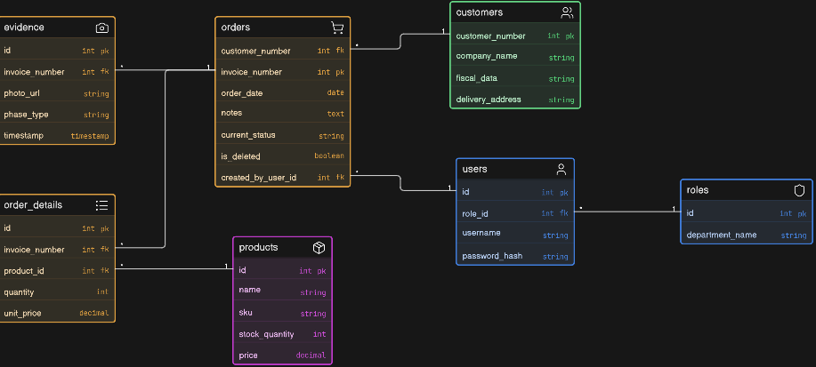

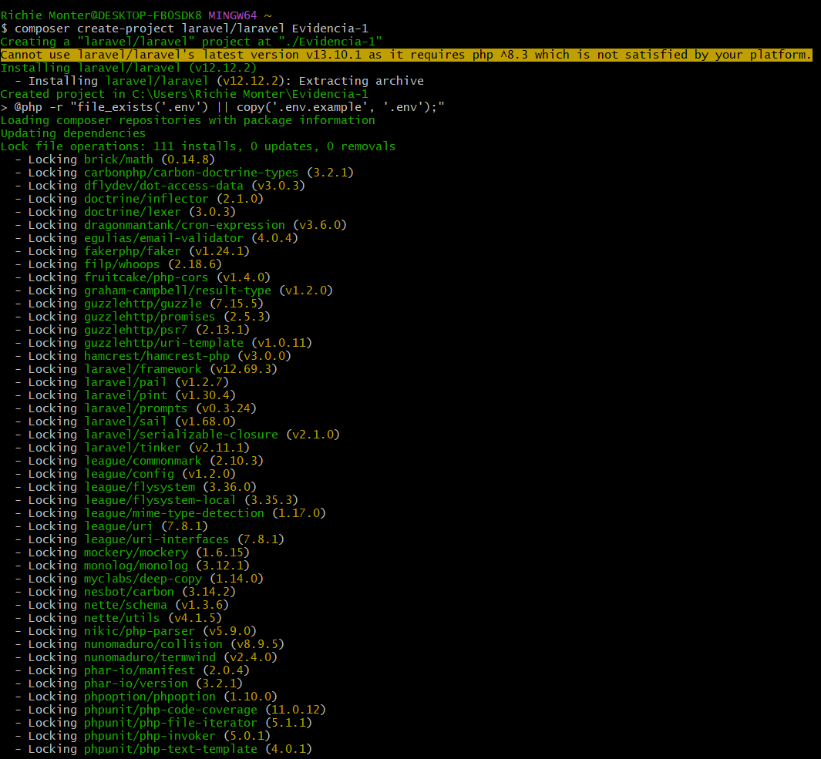
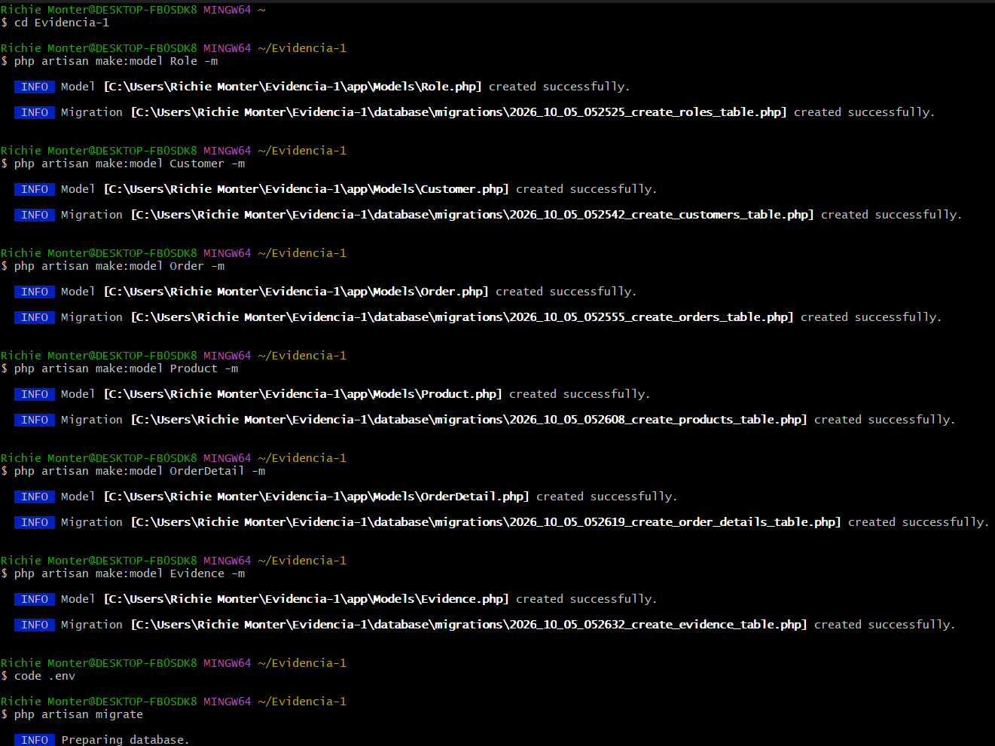
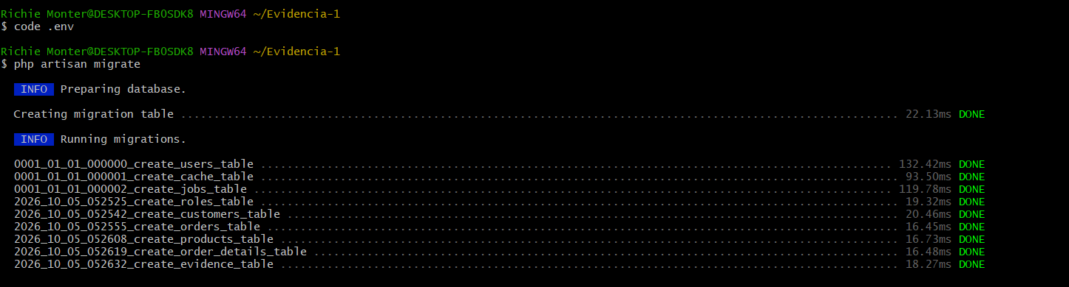
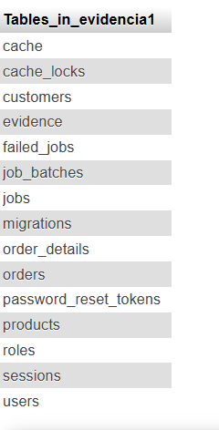
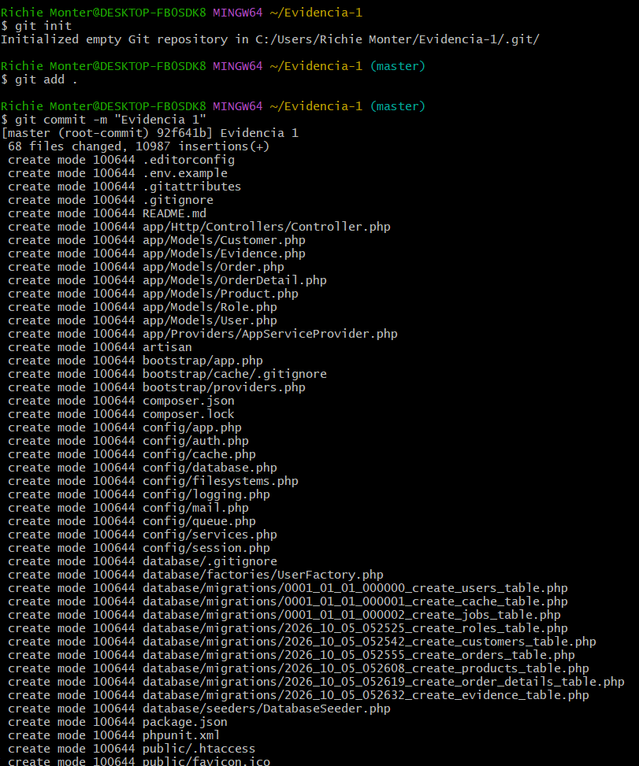
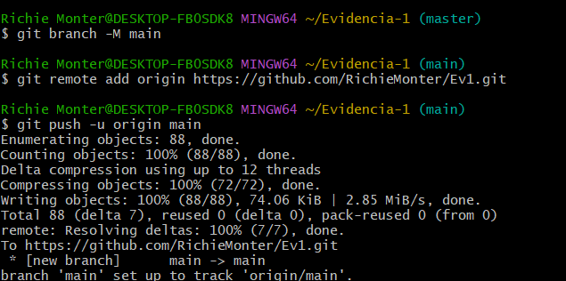
https://github.com/RichieMonter/Ev1

